# Data analysis of retail orders

* find the top 10 highest revenue generating products

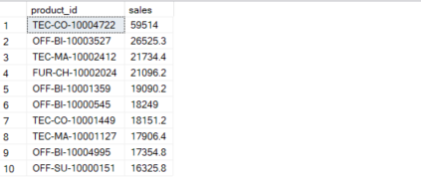

* Find top 5 highest selling products in each region

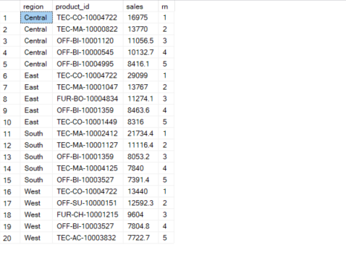

* find month over month growth comparison for 2022 and 2023 sales eg : jan 2022 vs jan 2023

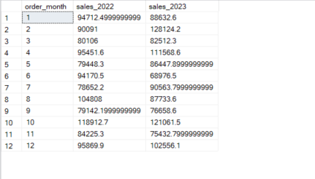

* for each cateogry which month had highest sales

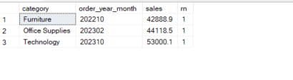

* which sub category had highest growth by profit in 2023 compare to 2022

